Management’s Discussion and Analysis

For the Fiscal Year Ended June 30, 2021

This section of the Carolina County Board of Education’s (Board)financial report presents our discussion and analysis of the financial performance of the Board for the year ended June 30, 2021. This information should be read in conjunction with the audited financial statements included in this report.

**Note to preparer.** The MD&A is an opportunity for management to proactively address any issues that might be affecting the Board’s financial status or questions that might be posed by readers of the financial statements. A thoughtful discussion and analysis of economic, financial or budgetary factors that might impact the Board should be presented.

# Financial highlights

* Financial highlights regarding the financial impact of COVID should be presented.
* The Board enjoyed an increased enrollment of 136 students (or 4%) from the previous year.
* The Board is constructing a new building to accommodate the increased enrollment and to allow it to offer an expanded curriculum to its students.
* The Board is working diligently with the Carolina County Board of Commissioners to find ways to fund increases in supplemental pay for teachers and to fund the continuing need for additional classroom space.
* Excessive mold contamination was discovered at Cardinal Senior High School resulting in an extraordinary impairment loss of $369,090. Demolition and mold removal expenses of $380,000 were incurred. Restoration costs of $570,000 have been capitalized.

**Overview of the financial statements**

The audited financial statements of the Carolina County Board of Education consist of four components. They are as follows:

* Independent Auditor’s Report
* Management's Discussion and Analysis (required supplementary information)
* Basic Financial Statements
* Required supplemental information section presents schedules for Teachers' and State Employees' Retirement System, Retiree Health Benefit Fund, Disability Income Plan of North Carolina and combining and budgetary statements for non-major governmental funds and budgetary statements for enterprise funds

The *Basic Financial Statements* include two types of statements that present different views of the Board’s finances. The first is the *government-wide statements*. The government-wide statements are presented on the full accrual basis of accounting and include the statement of net position and the statement of activities. The Statement of Net Position includes all of the Board’s assets, deferred outflows of resources, liabilities, and deferred inflows of resources. Assets and liabilities are classified in the order of relative liquidity for assets and due date for liabilities. This statement provides a summary of the Board's investment in assets, deferred outflows and inflows of resources, and obligations to creditors. Liquidity and financial flexibility can be evaluated using the information contained in this statement. The Statement of Activities summarizes the Board’s revenues and expenses for the current year. A net (expense) revenue format is used to indicate to what extent each function is self-sufficient.

**Note to preparer**: Only applicable elements of the financial statements should be mentioned. If the Board of Education has no items which meet the criteria for deferred outflows of resources, deferred outflows of resources should not be mentioned as a component of the Statement of Net Position. If a unit has deferred outflows, applicable references should be included in this paragraph. For example, the fourth sentence would read, “The Statement of Net Position includes all of the Board’s assets, deferred outflows of resources, liabilities, and deferred inflows of resources.”

The second set of statements included in the basic financial statements isth*e Fund Financial Statements,* which are presented for the Board’s governmental funds, proprietary funds, and fiduciary fund. These statements present the governmental funds on the modified accrual basis of accounting, measuring the near-term inflows and outflows of financial resources and what is available at year-end to spend in the next fiscal year. The proprietary and fiduciary funds are presented on the full accrual basis of accounting. The fund financial statements focus on the Board’s most significant funds. Because a different basis of accounting is used in the government-wide statements, a reconciliation from the governmental fund financial statements to the government-wide statements is required. The government-wide statements provide information about the Board as an economic unit while the fund financial statements provide information on the financial resources of each of the Board’s major funds.

**Government-wide statements**

The government-wide statements report information about the unit as a whole using accounting methods similar to those used by private-sector companies. The Statement of Net Position includes all the Board’s assets, deferred outflows of resources, deferred inflows of resources, and liabilities. All the current year’s revenues and expenses are accounted for in the Statement of Activities regardless of when cash is received or paid.

The two government-wide statements report the board’s net position and how it has changed. Net position – the difference between the board’s total of assets and deferred outflows of resources and the total of liabilities and deferred inflows of resources – is one way to measure the Board’s financial health.

* Over time, increases or decreases in the Board’s net position are an indicator of whether its financial position is improving or deteriorating.
* To assess the Board’s overall health, one should consider additional non-financial factors such as changes in the County’s property tax base and the condition of its school buildings and other physical assets.

The unit’s activities are divided into two categories in the government-wide statements:

* Governmental activities: Most of the Board’s basic services are included here, such as regular and special education, transportation, and administration. County funding and state and federal aid finance most of these activities.
* Business-type activities: The Board charges fees to help it cover the costs of certain services it provides. School food service and childcare services are included here.

The government-wide statements are Exhibits 1 and 2 of this report.

**Fund financial statements**

The fund financial statements provide detailed information about the Board’s funds, focusing on its most significant or “major” funds. Funds are accounting devices the Board uses to keep track of specific sources of funding and spending on particular programs.

* Some funds are required by state law, such as the State Public School Fund.
* The Board has established other funds, such as the Federal Grants fund, to control and manage money for particular purpose or to show that it is properly using certain revenues.

Carolina County Board of Education has three types of funds:

*Governmental funds:* Most of the Board’s basic services are included in the governmental funds, which generally focus on two things – how cash and other assets can readily be converted to cash flow in and out and the balances left at year-end that are available for spending. As a result of this focus, the governmental funds statements provide a detailed short-term view that helps the reader determine whether there are more or fewer financial resources that can be spent in the coming year to finance the Board’s programs. Because this information does not encompass the additional long-term focus of the government-wide statements, a reconciliation following the governmental funds statements, explains the relationship (or differences) between the government-wide and the fund financial statements. The Board has several governmental funds: the General Fund, the State Public School Fund, the Individual Schools Fund, the Capital Outlay Fund, and the Federal Grants Fund.

The governmental fund statements are Exhibits 3, 4, 5 and 6 of this report.

*Proprietary funds:* Services for which the Board charges a fee are generally reported in the proprietary funds. The proprietary fund statements are reported on the same full accrual basis of accounting as the government-wide statements. Carolina County Board of Education has two proprietary funds – both enterprise funds – the School Food Service Fund and the Child Care Fund.

The proprietary fund statements are Exhibits 7, 8 and 9 of this report.

*Fiduciary fund:* Fiduciary funds are used to account for resources held for the benefit of parties outside the government. Carolina County Board of Education has one fiduciary fund – the Administrative Fund, which is a scholarship fund under the control of the Board. This is accounted for as a private purpose trust fund.

The fiduciary fund statements are Exhibits 10 and 11 of this report.

# Financial analysis of the board as a whole

Net position is an indicator of the fiscal health of the Board. Assets and deferred outflows of resources exceeded liabilities and deferred inflows of resources for Governmental Activities by $14.0 million as of June 30, 2021. The largest component of net position is net investment in capital assets, of $15.1 million.

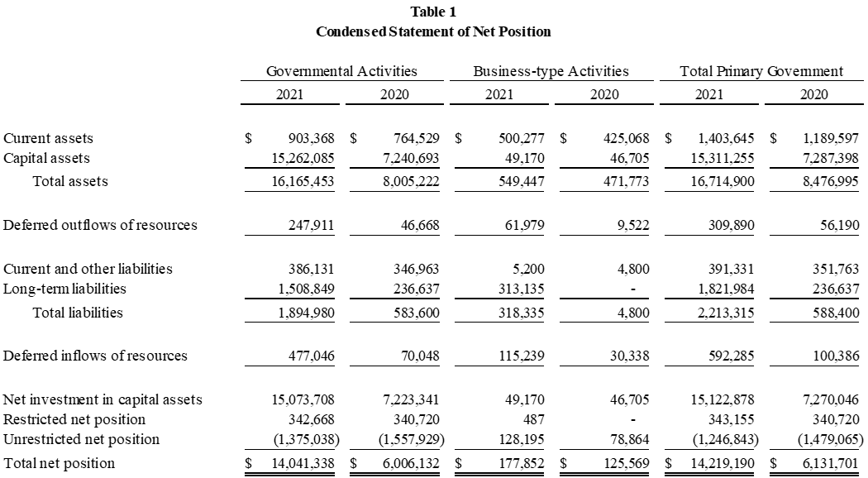

**Note to preparer.** GASBS 34 ¶9. Indicates that the “MD&A should discuss the current-year results in comparison with the prior year, with emphasis on the current year. This fact-based analysis should discuss the positive and negative aspects of the comparison with the prior year. The use of charts, graphs, and tables is encouraged to enhance the understandability of the information.”

GASBS 34 ¶11.c. provides for, at a minimum, inclusion of “[a]n analysis of the government's overall financial position and results of operations to assist users in assessing whether financial position has improved or deteriorated as a result of the year's operations. The analysis should address both governmental and business-type activities as reported in the government-wide financial statements and should include *reasons* for significant changes from the prior year, not simply the amounts or percentages of change. In addition, important economic factors, such as changes in the tax or employment bases, that significantly affected operating results for the year should be discussed.”

Following is a summary of the Statement of Net Position

Note that net position increased during the year, indicating an improvement in the financial condition of the Board. The $8.1 million or 133.8% increase in governmental activities net position was largely due to an increase of $8.0 million or 101.9%, in capital assets because of new school construction. Unrestricted net position increased in the business-type activities primarily because of an increase in current assets in the School Food Service fund. Also, note that the Board carries capital assets for which Carolina County issues and carries the offsetting debt.

Proportion of assets of the total primary government are presented below are reported at cost:

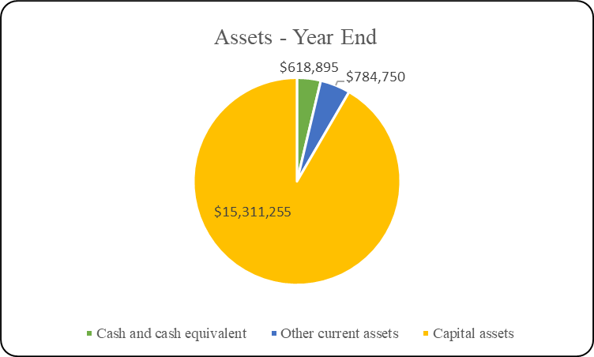

The following table shows the revenues and expenses for the Board for the most recent two fiscal years.



Total governmental activities generated revenues of $161.8 million or a decrease of 13.9%, while expenses in this category totaled $153.4 million, a 17.4% decline, for the year ended June 30, 2021. Comparatively, revenues were $188.1 million, and expenses totaled $185.6 million for the year ended June 30, 2020. After transfers to the business-type activities, the increase in net position stands at $8.1 million at June 30, 2021, compared to $2.6 million in 2020, a 226.9% increase. County funding comprised 25.2% of total governmental revenue for 2021. In 2020, county funding was 23.5%. Much of the remaining 74.8% of total governmental revenue for 2021 consists of restricted State and federal money. This revenue represented 70.69% of total revenue in 2020. Business-type activities generated revenue of $1.3 million and expenses of $1.2 million. Net position increased in the business-type activities by $52 thousand after transfers from the governmental activities of $14 thousand.

Proportion of revenues presented below are reported on the full accrual basis of accounting:

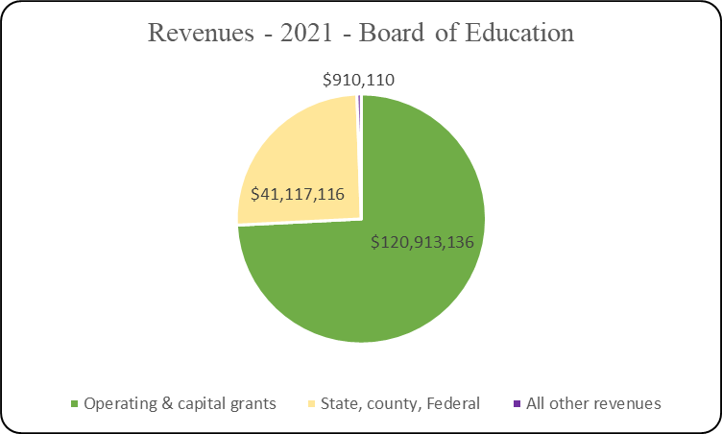

Instructional services expenses of $127.5 million represents an increase of 12.8% and comprised 83.1% of total governmental-type expenses while system-wide support services made up 16.10% of those expenses for 2021. Comparatively, instructional services expenses were $112.9 million and support services were $72.5 million for the year ended June 30, 2020. Results for 2021 also included the extraordinary loss of $369 thousand due to mold damage.

Proportion of expenses presented below are reported on the full accrual basis of accounting:

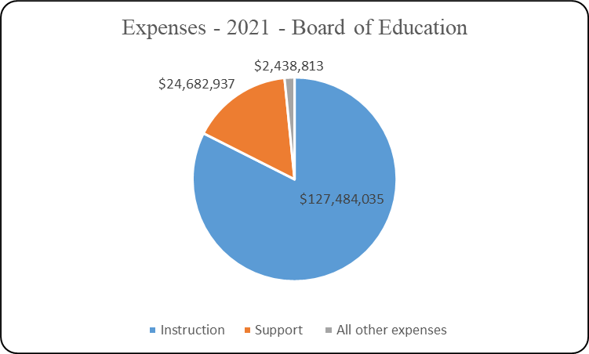

An important factor effecting the level of revenue and expense is student enrollment. In the fiscal year ended June 30, 2021, enrollment increased 4.2% to 3,400 students. Enrollment trends for the past five years are shown in the following graph.

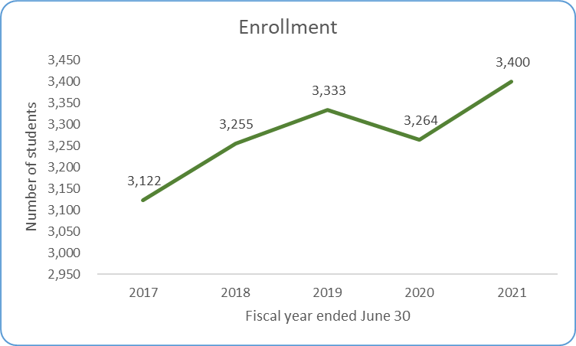

**Financial analysis of the Board’s funds**

Governmental funds: The focus of Carolina County Board of Education’s governmental funds is to provide information on near-term inflows, outflows, and balances of usable resources. Such information is useful in assessing the Board’s financing requirements.

**Note to Preparer.** GASBS 34 ¶11.d. provides for, at a minimum, inclusion of “[a]n analysis of balances and transactions of individual funds. The analysis should address the reasons for significant changes in fund balances or fund net assets and whether restrictions, commitments, or other limitations significantly affect the availability of fund resources for future use.

The Board’s governmental funds reported a combined fund balance of $500 thousand, a $295 thousand increase over last year on revenues of $161.9 million or x.x%. Fund revenue totals include General Fund, $33.1 million; State Public School Fund, $119.0 million; and Capital Outlay Fund, $8.9 million. Governmental funds expenditures totaled $161.8 million, an increase of x.x%. and included $9.1 million in capital outlay. Fund expenditures include $32.9 million for the General Fund; $119.0 million for the State Public School Fund; and $9.1 million for the Capital Outlay Fund. The fund balance of the General Fund increased $147 thousand to $174 thousand.

Proprietary funds: The Board’s business-type funds performed well in the past year, although the Child Care Fund reflected a decrease in net position over last year due to higher-than-expected maintenance costs for some equipment. Revenues and expenses remained constant overall; however, non-operating revenue brought about most of the increase in net position with increases in federal reimbursements and investment earnings.

**General Fund budgetary highlights**

Over the course of the year, the Board revised the budget several times to account for changes in revenue expectations and to modify appropriations considering the altered revenue estimates. With the increases in revenue, the Board was able to adjust spending and end the year with a small surplus. Changes in estimated revenues and corresponding revisions in budgeted appropriations totaled $160 thousand in the General Fund.

### Capital assets

Capital assets increased by $8.0 million (or 110.1%) from the previous year. This was largely due to new construction, specifically the construction of elementary and high schools, the purchase of new buses, and the restoration project at Cardinal Senior High School. Excessive mold contamination was discovered at Cardinal Senior High School resulting in an extraordinary impairment loss of $369 thousand. Demolition and mold removal expenses of $380 thousand were incurred. Restoration costs of $570 thousand have been capitalized.

**Note to preparer.** GASBS 34 ¶11.d. provides for, at a minimum, inclusion of “[a] description of significant capital asset and long-term debt activity during the year, including a discussion of commitments made for capital expenditures, changes in credit ratings, and debt limitations that may affect the financing of planned facilities or services.

The following is a summary of the capital assets net of depreciation at year-end.



**Debt outstanding**

During the year the Board’s outstanding debt increased by $171 thousand due mainly to the use of installment financing to pay for energy conservation measures and school buses. The Board is limited by North Carolina General Statutes with regards to the types of debt it can issue and for what purpose that debt can be used. The County holds virtually all debt issued for school capital construction.

The following is a summary of the outstanding debt at year-end.



### Economic factors

The Board anticipates an increased enrollment over the next several years and will need continued increases in classroom space, teachers, and equipment. County funding is a major source of income for the Board; therefore, the County’s economic outlook directly affects that of the schools.

**Note to preparer**: GASBS 34 ¶11.h. provides for, at a minimum, inclusion of “…a description of currently known facts, decisions, or conditions that are expected to have a significant effect on financial position (net assets) or results of operations (revenues, expenses, and other changes in net assets).

The following factors have positively [or adversely] affected the economic outlook of Carolina County.

* The County is enjoying a low unemployment rate of 3.9%, lower than the state average of 4.5%.
* Retail vacancy rates are low, having stayed in the 5-10% range all year.
* New manufacturing jobs were created in the last year bringing 400 new jobs to the County.

**Impact of Coronavirus on Board.** During the fiscal year, the state and the nation were affected by the spread of a coronavirus. The Board’s response to the coronavirus included *please describe*. *Describe the financial and economic effects that the coronavirus has had on your School during the* *year and any action taken to moderate the impact.*

*The GASB* ***“Emergency Toolbox”*** *designed to help quickly identify the authoritative guidance that could be relevant to the current circumstances may be found* [*here*](https://www.gasb.org/cs/Satellite?c=Page&cid=1176174469582&pagename=GASB%2FPage%2FGASB%2FSectionPage)*. North Carolina Local Government COVID-19 resources may be found* [*here*](https://www.nctreasurer.com/local-government-covid-19-resources)*.*

# Requests for information

This report is intended to provide a summary of the financial condition of Carolina County Board of Education. Questions or requests for additional information should be addressed to:

Name, Finance Officer

Carolina County Board of Education

1111 Government Drive

Dogwood, NC 00000

(This page left blank intentionally.)

**Basic Financial Statements**

(This page left blank intentionally.)