Management’s Discussion and Analysis

**For the Year Ended June 30, 2020**

As management of Owl Charter, Inc. (“Owl”), we provide these financial statements and this narrative overview and analysis of Owl’s financial position at June 30, 2020 and its operations for the year then ended. We encourage readers to review the discussion presented here in conjunction with additional information included in the financial statements and notes which follow this section.

# Financial Highlights

* The assets of Owl exceeded its liabilities and deferred inflows at the close of the fiscal year by $1,662,143 ***(net position)***.
* The government’s total net position increased by $115,450, primarily due to an increasein the governmental activities’ net position.
* At of the close of the current fiscal year, Owl’s governmental funds reported combined ending fund balances of $746,992, a decrease of $63,081 in comparison with the prior year.
* Enrollment continues to increase at the three charter schools with Owl – Doceo’s enrollment rising by 19 students this past year, a 4.5% increase. Student enrollment totaled 439, 420 and 398 in years 2020, 2019 and 2018, respectively. Owl – Erudio’s enrollment was stable at 455, 452 and 454 in years 2020, 2019 and 2018. In the newest school, Owl – Discite, enrollment continued to increase, rising 8.6% to 327 from 301 in 2019 and 284 in 2018.
* During the current fiscal year, Owl’s total long-term debt increasedby $577,383 to $8,193,183. The key factor in this increase was the new capital lease entered into by Owl for the lease purchase of a new building. The total new lease amount is $650,000.

# Overview of the Financial Statements

This discussion and analysis are intended to serve as an introduction to Owl’s basic financial statements. Owl’s basic financial statements consist of three components: the government-wide financial statements, the fund financial statements, and the notes to the financial statements. The basic financial statements present two different views of Owl through the use of government-wide statements and fund financial statements. In addition to the basic financial statements, the annual financial report contains the independent auditor’s report, certain required supplementary information and other required schedules that provide additional information to enhance the reader’s understanding of the financial position and activities of the schools.

**Note to Preparer:** The following chart (Figure 1) is appropriate for a charter school that provides pension and OPEB-related benefits. A chart suitable for charter schools that do not provide pension and OPEB-related benefits is also available and is included as an appendix to the Word document MD&A samples in Cardinal Charter, Inc. (Times New Roman font) and Owl School, Inc. (Arial font) The presentation as Figure 1 from prior versions can also be used.

The chart in Figure 1 outlines the relationships of the components of the annual financial report.

## Components of Annual Financial Report

Figure 1

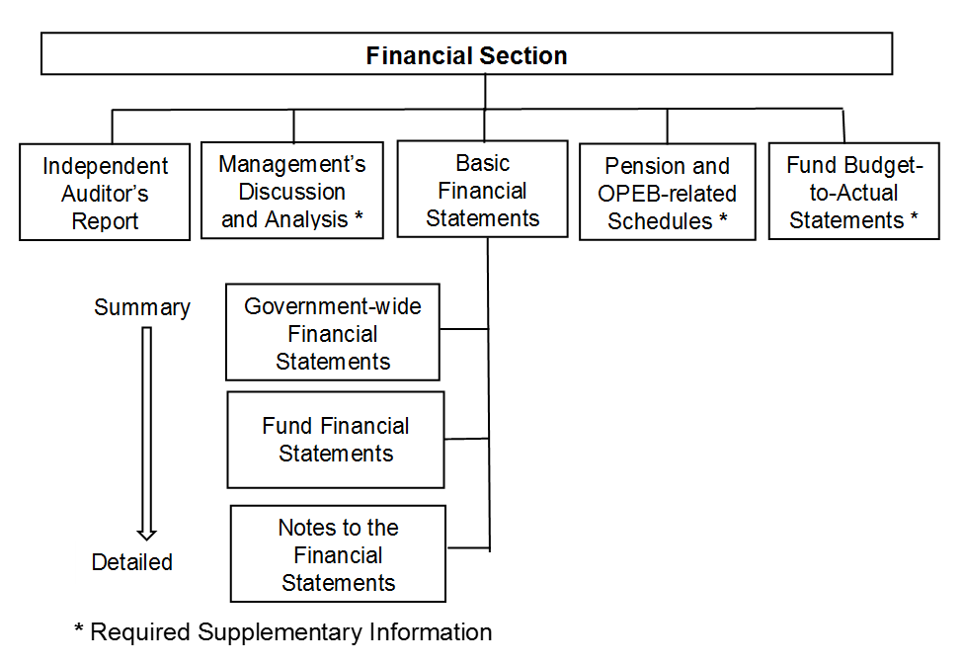

**Basic Financial Statements**

The first two statements (Exhibits 1 and 2) in the basic financial statements are the **Government-wide Financial Statements**. They provide both short and long-term information about Owl’s financial status.

The next statements (Exhibits 3 through 7) are **Fund Financial Statements**. These statements focus on the activities of the individual parts of Owl. These statements provide more detail than the government-wide statements. There are two parts to the Fund Financial Statements: the governmental funds statements and the proprietary funds statements.

The next section of the basic financial statements is the **notes**. The notes to the financial statements explain in detail some of the data contained in those statements. After the notes, **supplemental information** is provided to show details about each school’s individual funds. Budgetary information for the schools also can be found in this section of the statements.

# Government-wide Financial Statements

The government-wide financial statements are designed to provide the reader with a broad overview of Owl’s finances, similar in format to a financial statement of a private-sector business. The government-wide statements provide short and long-term information about Owl’s financial status as a whole.

The two government-wide statements report Owl’s net position and how it has changed. Net position is the difference between Owl’s total assets plus deferred outflows of resources minus the total of liabilities plus deferred inflows of resources. Measuring net position is one way to gauge Owl’s financial condition.

The government-wide statements are divided into two categories: governmental activities and business-type activities. The governmental activities include most of the Owl’s basic functions such as instructional services and business services. State, county and federal funds provide virtually all the funding for these functions. The business-type activities are those services for which the schools charge its students and other customers to provide. These include the Food Service and Childcare services offered by each school.

The condensed government-wide financial statements are provided in Exhibits 1 and 2 of this report.

# Fund Financial Statements

The fund financial statements provide a more detailed look at the schools most significant activities. A fund is a grouping of related accounts that is used to maintain control over resources that have been segregated for specific activities or objectives. The schools, like all other governmental entities in North Carolina, use fund accounting to ensure and reflect compliance (or non-compliance) with finance-related legal requirements, such as the North Carolina General Statutes or Owl’s budget ordinances. All of the funds of Owl can be divided into two categories: governmental funds and proprietary funds.

**Governmental Funds** – Governmental funds are used to account for those functions reported as governmental activities in the government-wide financial statements. Most of the Owl’s basic services are accounted for in the governmental funds. These funds focus on how assets can readily be converted into cash flow in and out, and what monies are left at year-end that will be available for spending in the next year. Governmental funds are reported using an accounting method called *modified accrual accounting* that provides a short-term spending focus. As a result, the governmental fund financial statements give the reader a detailed short-term view that helps one determine if there are more or less financial resources available to finance the programs provide by the schools. The relationship between governmental activities (reported in the Statement of Net Position and the Statement of Activities) and governmental funds is described in a reconciliation that is a part of the fund financial statements.

Each school adopts an annual budget for each of its funds, although it is not required to do so by the General Statutes. Because the budget is not legally required by the statutes, the budgetary comparison statements are not included in the basic financial statements but are part of the supplemental statements and schedules that follow the notes. The budget is a legally adopted document that incorporates input from the faculty, management, and the Board of Directors of Owl in determining what activities will be pursued and what services will be provided by the school during the year. It also authorizes Owl to obtain funds from identified sources to finance these current period activities. The budgetary statement provided for each of the funds demonstrates how well the school has complied with the budget ordinance and whether or not the school has succeeded in providing the services as planned when the budget was adopted.

**Proprietary Funds** – Owl has two proprietary funds, both of which are enterprise funds. *Enterprise funds* are used to report the same functions presented as business-type activities in the government-wide financial statements. The schools use enterprise funds to account for its school food service and childcare functions.

**Notes to the Financial Statements** – The notes provide additional information that is essential to a full understanding of the data provided in the government-wide and fund financial statements. The notes to the financial statements begin on page 25 of this report.

# Government-Wide Financial Analysis

**Note to Preparer.** GASBS 34 ¶9. Indicates that the “MD&A should discuss the current-year results in comparison with the prior year, with emphasis on the current year. This fact-based analysis should discuss the positive and negative aspects of the comparison with the prior year. The use of charts, graphs, and tables is encouraged to enhance the understandability of the information.”

GASBS 34 ¶11.c. provides for, at a minimum, inclusion of “[a]n analysis of the government's overall financial position and results of operations to assist users in assessing whether financial position has improved or deteriorated as a result of the year's operations. The analysis should address both governmental and business-type activities as reported in the government-wide financial statements and should include *reasons* for significant changes from the prior year, not simply the amounts or percentages of change. In addition, important economic factors, such as changes in the tax or employment bases, that significantly affected operating results for the year should be discussed.”

The financial analysis reveals that at June 30, 2020 cash and cash equivalents, and other current assets , primarily amounts due from other govenments, accounted for 15.5% and 1.0% of total government-wide assets, respectively. These relationships were little changed from the prior year. During the 2020 fiscal year, the school entered into the long-term lease of a classroom building. This transaction accounted for $650,000 of the increase in capital assets and long-term liabilities, which increased of 6.5% and 2.8% respectively. Capital assets, net of accumulated depreciation, accounted for 83.5% of total assets. Long-term liabilities represent 84.8% of total liabilities.

As previously noted, net position may, over time, serve as one useful indicator of a school’s financial condition. The assets of Owl increased by 17.4% and exceeded liabilities and deferred inflows of resources by $1,662,143. At June 30, 2019, the net position of Owl stood at $1,546,693. Owl’s net position increased by $115,450 for the fiscal year ended June 30, 2020, compared to a decrease of $48,267 in 2019. Owl’s investment in capital assets (e.g. land, buildings, furniture and school-related equipment) less outstanding debt issued to acquire those items represents the 56.3% portion of total net position. The schools use these capital assets to provide services to its students; consequently, these assets are not available for future spending. Although Owl’s net investment in capital assets is reported net of the outstanding related debt, the resources needed to repay that debt must be provided by other sources, since the capital assets cannot be used to liquidate these liabilities. The remaining net asset position, $725,569 is unrestricted. In 2019, the amount of net investment in capital assets was $918,379 with unrestricted net position standing at $628,314.

A condensed statement of net position which summarizes the assets, liabilities, deferred inflows of resources and net position at June 30, 2020 and 2019 is as follows:



Several aspects of the schools’ financial operations positively influenced the total unrestricted governmental net position:

## Owl adopted an annual budget for all funds. The performance of each school was measured on a monthly basis using these budgets allowing changes in spending as needed to stay within the budget.

* The schools applied for and were awarded several federal grants to assist with the expenses of meeting the education needs of extremely academically gifted children.
* Management is capitalizing on the population boom in the tri-county area and is focusing efforts on attracting students throughout the region. Funding increased by 12.2% reflecting both the increase in the student population and the various fund-raising activities.

Revenues, expenses and the change in net position is summarized in the following condensed statement of activities for the year ended June 30, 2020 and 2019:



**Governmental activities**: Governmental activities increased Owl’s net position by $86,779, compared to a decrease in net position of $55,055 in the prior year. The increase in revenues of $500,765 and was partially offset by an increase in expenses of $358,931. County, State and federal funds of $4,006,965 increased by 4.2% and make up 86.9% of total revenues. Instructional service and related expenses of $3,061,824 account for 67.7% of total expenses and decreased by 1.7%. This reflects both increased program and general revenues offset against increased costs of providing instructional services and interest on long-term debt. As compared to 2019, the change in net position increased $141,834.

**Business-type activities**: Business-type activities increased Owl’s net position by $28,671 up from $6,785 in 2019, primarily related to growth of both the food service activities and the childcare program. The school food services generated operating revenues of $50,223 and federal reimbursements of $46,351 while food cost and other operating expenses totaled $73,029. The childcare services generated operating revenues of $18,446 while operating expenses totaled $14,254. The net change in position from school food services and childcare services totaled $23,545 and $5,126, respectively.

Key elements of this increase are as follows:

* By adopting a budget for each of the enterprise funds that comprise the business-type activities, the Board can monitor the revenues and expenditures of the schools and adjust their estimates as needed during the year.
* Owl received $46,351 of federal reimbursement funds in the School Food Service Funds this past year, a 15.2% increase over the prior year.

## Financial Analysis of Owl’s Funds

**Note to Preparer.** GASBS 34 ¶11.d. provides for, at a minimum, inclusion of “[a]n analysis of balances and transactions of individual funds. The analysis should address the reasons for significant changes in fund balances or fund net assets and whether restrictions, commitments, or other limitations significantly affect the availability of fund resources for future use.”

As previously noted, Owl uses fund accounting to ensure and demonstrate compliance with finance-related legal requirements.

**Governmental Funds**. The focus of Owl’s governmental funds is to provide information on near-term inflows, outflows, and balances of usable resources. Such information is useful in assessing each schools’ financing requirements. Specifically, unassigned fund balance can be a useful measure of a government’s net resources available for spending at the end of the fiscal year.

The General Fund is the chief operating fund of Owl. At the end of the current fiscal year, the assets in the General Fund consisted primarily of cash and cash equivalents which equaled 99.6% of total fund assets. Accounts payable and accrued liabilities accounted for the General Fund liabilities. The unassigned fund balance of the General Fund was $386,491, while total fund balance reached $416,916, an increase of $64,425 or 18.3%. The unassigned fund balance of the General Fund was 92.7% of total fund balance. The primary source of General Fund revenue was $69,425 in contributions, donations and other revenues.

Activities of the individual schools are reported in special revenue funds. An additional $3,935,495, or 88.1% of total revenue of all governmental funds, was provided by the State of North Carolina and Carolina County. Expenditures for capital outlays including the new classroom facility totaled $750,000, or 14.2% of governmental funds expenditures. Additional instructions-related expenditures of $4,112,522 and debt service of $414,167 accounted for 77.9% and 7.8%, respectively, of governmental funds expenditures.

At June 30, 2020, the governmental funds of Owl reported a combined fund balance of $746,992, a 7.8% decline over last year.

**Proprietary Funds**. Owl’s proprietary funds provide the same type of information found in the government-wide statements but in more detail. Unrestricted net position of the School Food Service Fund at the end of the fiscal year amounted to $11,488. The total growth in net position for the School Food Service fund was $23,545 reflecting the growth in the student population and effective operation of the school service facilities. More parents are taking advantage of Owl’s childcare programs with revenues increasing to $18,446 and operating income reaching $4,282.

# Capital Asset and Debt Administration

**Note to Preparer.** GASBS 34 ¶11.d. provides for, at a minimum, inclusion of “[a] description of significant capital asset and long-term debt activity during the year, including a discussion of commitments made for capital expenditures, changes in credit ratings, and debt limitations that may affect the financing of planned facilities or services.”

**Capital assets.** Owl’s investment in capital assets for its governmental and business–type activities as of June 30, 2020, totals $9,090,269 (net of accumulated depreciation). These assets include the building, and various equipment, furniture and electronic equipment.

The major capital asset transaction during the year includes the following addition:

## Owl entered into a capital lease for a new building in which to hold classes with the total lease purchase price of $650,000.

## The following schedule summarizes Owl’s capital assets as June 30, 2020 and 2019:



Additional information on each school’s capital assets can be found in Note III.A.2. of the Basic Financial Statements.

**Long-term Debt**. As of June 30, 2020, Owl had total debt outstanding of $8,193,183. The debt consists of $782,177 of capital lease obligations, a $100,000 note payable with Bank of Dogwood, $7,271,518 in revenue bonds outstanding and $39,488 for compensated absences.

Owl’s outstanding debt at June 30, 2020 and 2019 is summarized in the following schedule:



Owl’s total debt increased by $577,383 during the past fiscal year due to the $650,000 in capital lease financing issued for the lease purchase of a new classroom building and the $100,000 note issued less principal payments of $173,000. The obligation for compensated absences increased $383.

##### Economic Factors

**Note to Preparer.** GASBS 34 ¶11.h. provides for, at a minimum, inclusion of “…a description of currently known facts, decisions, or conditions that are expected to have a significant effect on financial position (net assets) or results of operations (revenues, expenses, and other changes in net assets).”

The following key economic indicators reflect the growth and prosperity of Owl:

* The low unemployment rate (4.9%) in the tri-county area has increased revenues in the three counties and contributed to the increased funding to all public schools in the area, including charter schools.
* Though cutbacks in federal funding to education have resulted in a reduction of federal revenue for the School of 5% over the next year, the increase in each school’s enrollment will generate more revenue overall.
* The high growth rate (20%) of the tri-county area is anticipated to increase the number of students in the schools over the next three years. Each school estimates the growth rate in enrollment to continue at a 10–15% increase each year for the next three years.

**Impact of Coronavirus on Owl.** During the fiscal year, the state and the nation were affected by the spread of a coronavirus. The Owl’s response to the coronavirus included *please describe*. *Describe the financial and economic effects that the coronavirus has had on Owl during the* *year and any action taken to moderate the impact.*

*The GASB* ***“Emergency Toolbox”*** *designed to help quickly identify the authoritative guidance that could be relevant to the current circumstances may be found* [*here*](https://www.gasb.org/cs/Satellite?c=Page&cid=1176174469582&pagename=GASB%2FPage%2FGASB%2FSectionPage)*. North Carolina Local Government COVID-19 resources may be found* [*here*](https://www.nctreasurer.com/local-government-covid-19-resources)*.*

**Requests for Information**

This report is designed to provide an overview of Owl’s finances for those with an interest in this area. Questions concerning any of the information found in this report or requests for additional information should be directed to the Finance Officer, Owl Charter, Inc., 500 Dogwood Lane, Dogwood, NC 00000‑0000, telephone (919) xxx‑xxxx. . Additional information is available at Owl’s website, [www.xxxxxxx.edu](http://www.xxxxxxx.edu).