Management’s Discussion and Analysis

**For the Year Ended June 30, 2021**

As management of Cardinal Charter, Inc. (“Cardinal” or the “School”), we provide these financial statements and this narrative overview and analysis of the School’s financial position at June 30, 2021 and its operations for the year then ended. We encourage readers to review the discussion presented here in conjunction with additional information included in the financial statements and notes which follow this section.

# Financial Highlights

* Financial highlights regarding the financial impact of COVID should be presented.
* The assets of the School exceeded its liabilities and deferred inflows at the close of the fiscal year by $475,693 ***(net position)***.
* The government’s total net position increased by $28,305, primarily due to an increasein the net position of the business-type activities.
* As of the close of the current fiscal year, the School’s governmental funds reported combined ending fund balances of $63,599, an increase of $ 48,003 in comparison with the prior year.
* Enrollment continues to increase at the School, rising by 19 students this past year, a 4.5% increase. Student enrollment totaled 439, 420 and 398 in years 2021, 2020 and 2019, respectively.
* During the current fiscal year, Cardinal’s total long-term debt increasedby $397,251 to $577,428. The key factor in this increase was the new capital lease entered into by the School for the lease purchase of a new building. The total lease amount is $400,000.

# Overview of the Financial Statements

This discussion and analysis are intended to serve as an introduction to Cardinal’s basic financial statements. The School’s basic financial statements consist of three components: the government-wide financial statements, the fund financial statements, and the notes to the financial statements. The basic financial statements present two different views of the School through the use of the government-wide statements and the fund financial statements. In addition to the basic financial statements, the annual financial report contains the independent auditor’s report, certain required supplementary information and other required schedules that provide additional information to enhance the reader’s understanding of the financial position and activities of the School.

**Note to Preparer:** The following chart (Figure 1) is appropriate for a charter school that does not provide pension and OPEB-related benefits. A chart suitable for charter schools that do provide pension and OPEB-related benefits is also available and is included as an appendix to the Word document sample Charter School MD&A. The presentation as Figure 1 from prior versions can also be used.

The chart in Figure 1 outlines the relationships of the components of the annual financial report.

## Components of Annual Financial Report

Figure 1

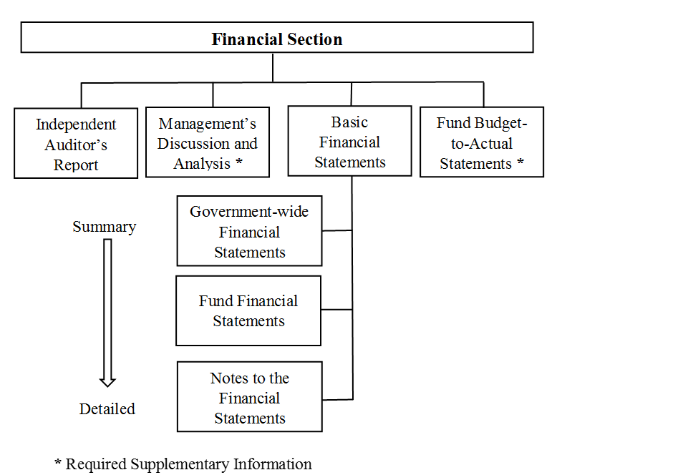

**Basic Financial Statements**

The first two statements (Exhibits 1 and 2) in the basic financial statements are the **Government-wide Financial Statements**. They provide both short and long-term information about the School’s financial status.

The next statements (Exhibits 3 through 8) are **Fund Financial Statements**. These statements focus on the activities of the individual parts of the School. These statements provide more detail than the government-wide statements. There are two parts to the Fund Financial Statements: 1) the governmental funds statements and 2) the proprietary funds statements.

The next section of the basic financial statements is the **notes**. The notes to the financial statements explain in detail some of the data contained in those statements. After the notes, **supplemental information** is provided to show details about the School’s individual funds. Budgetary information for the School also can be found in this section of the statements.

# Government-wide Financial Statements

The government-wide financial statements are designed to provide the reader with a broad overview of the School’s finances, similar in format to a financial statement of a private-sector business. The government-wide statements provide short and long-term information about the School’s financial status as a whole.

The two government-wide statements report the School’s net position and how it has changed. Net position is the difference between the School’s total assets plus deferred outflows of resources minus the total of liabilities plus deferred inflows of resources. Measuring net position is one way to gauge the School’s financial condition.

The government-wide statements are divided into two categories: 1) governmental activities; and 2) business-type activities. The governmental activities include most of the School’s basic functions such as instructional services and business services. State, county and federal funds provide virtually all of the funding for these functions. The business-type activities are those services for which the School charges its students and other customers to provide. These include the food service and childcare services offered by the School.

The condensed government-wide financial statements are provided in Figures 2 and 3 of this report.

# Fund Financial Statements

The fund financial statements provide a more detailed look at the School’s most significant activities. A fund is a grouping of related accounts that is used to maintain control over resources that have been segregated for specific activities or objectives. The School, like all other governmental entities in North Carolina, uses fund accounting to ensure and reflect compliance (or non-compliance) with finance-related legal requirements, such as the North Carolina General Statutes or the School’s budget ordinance. All of the funds of Cardinal can be divided into two categories: governmental funds and proprietary funds.

**Governmental Funds** – Governmental funds are used to account for those functions reported as governmental activities in the government-wide financial statements. Most of the School’s basic services are accounted for in governmental funds. These funds focus on how assets can readily be converted into cash flow in and out, and what monies are left at year-end that will be available for spending in the next year. Governmental funds are reported using an accounting method called *modified accrual accounting* that provides a short-term spending focus. As a result, the governmental fund financial statements give the reader a detailed short-term view that helps him or her determine if there are more or less financial resources available to finance the School’s programs. The relationship between governmental activities (reported in the Statement of Net Position and the Statement of Activities) and governmental funds is described in a reconciliation that is a part of the fund financial statements.

The School adopts an annual budget for each of its funds, although it is not required to do so by the General Statutes. Because the budget is not legally required by the statutes, the budgetary comparison statements are not included in the basic financial statements but are part of the supplemental statements and schedules that follow the notes. The budget is a legally adopted document that incorporates input from the faculty, management, and the Board of Directors of the School in determining what activities will be pursued and what services will be provided by the School during the year. It also authorizes the School to obtain funds from identified sources to finance these current period activities. The budgetary statement provided for each of the funds demonstrates how well the School has complied with the budget ordinance and whether the School has succeeded in providing the services as planned when the budget was adopted.

**Proprietary Funds** – Cardinal has two proprietary funds, both of which are enterprise funds. *Enterprise funds* are used to report the same functions presented as business-type activities in the government-wide financial statements. The School uses enterprise funds to account for the net position, the change in net position and the cash flows for the school food service and the childcare services.

**Notes to the Financial Statements** – The notes provide additional information that is essential to a full understanding of the data provided in the government-wide and fund financial statements. The notes to the financial statements begin on page 31 of this report.

# Government-Wide Financial Analysis

**Note to Preparer.** GASBS 34 ¶9. Indicates that the “MD&A should discuss the current-year results in comparison with the prior year, with emphasis on the current year. This fact-based analysis should discuss the positive and negative aspects of the comparison with the prior year. The use of charts, graphs, and tables is encouraged to enhance the understandability of the information.”

GASBS 34 ¶11.c. provides for, at a minimum, inclusion of “[a]n analysis of the government's overall financial position and results of operations to assist users in assessing whether financial position has improved or deteriorated as a result of the year's operations. The analysis should address both governmental and business-type activities as reported in the government-wide financial statements and should include *reasons* for significant changes from the prior year, not simply the amounts or percentages of change. In addition, important economic factors, such as changes in the tax or employment bases, that significantly affected operating results for the year should be discussed.”

The financial analysis reveals that at June 30, 2021 cash and cash equivalents, and other current assets , primarily amounts due from other govenments, accounted for 8.3% and 10.4% of total government-wide assets, respectively. These relationships were little changed from the prior year. During the 2021 fiscal year, the school entered into the lease long-term of a classroom building. This transaction accounted for $400,000 of the increase in capital assets and long-term liabilities, increases of 61.4% and 190.4% respectively. Capital assets, net of accumulated depreciation, accounted for 81.3% of total assets. Long-term liabilities represent 76.1% of total liabilities.

As previously noted, net position may, over time, serve as one useful indicator of a school’s financial condition. The assets of the School exceeded liabilities and deferred inflows of resources by $475,693 as of June 30, 2021. At June 30, 2020, the net position of the School stood at $447,388. The School’s net position increased by $28,305 for the fiscal year ended June 30, 2021, compared to an increase of $15,360 in 2020. The School’s investment in capital assets (e.g. land, buildings, furniture and school-related equipment) less outstanding debt issued to acquire those items represents the largest portion of total net position (84.0%). The School uses these capital assets to provide services to its students; consequently, these assets are not available for future spending. Although the School’s net investment in capital assets is reported net of the outstanding related debt, the resources needed to repay that debt must be provided by other sources, since the capital assets cannot be used to liquidate these liabilities. The remaining net asset amount, $76,107, is unrestricted. In 2020, the amount of net investment in capital assets was $412,909 with unrestricted net position standing at $34,479.

A condensed statement of net position which summarizes the assets, liabilities, deferred inflows of resources and net position at June 30, 2021 and 2020 is as follows:



Several aspects of the School’s financial operations contributed to the improvement in the total unrestricted governmental net position:

## The School adopted an annual budget for all funds except the Clubs and Activities Fund. The School’s performance was measured using these budgets on a monthly basis, allowing changes in spending as needed to stay within the budget.

* The School applied for and was awarded several federal grants to assist with the expenses of meeting the education needs of extremely academically gifted children.
* Management is capitalizing on the population boom in the tri-county area and is focusing efforts on attracting students throughout the region. Funding increased by 12.9% reflecting both the increase in the student population and the various fund-raising activities.

Revenues, expenses, transfers and the change in net position is summarized in the following condensed statement of activities for the years ended June 30, 2021 and 2020:



**Governmental activities**: Governmental activities decreased the School’s net position by $369. County, State and federal funds of $500,472 increased by 12.1% make up 87.7% of total revenues. Instructional service and related expenses of $495,995 account for 98.8% of total expenses and increased by 11.8%. This reflects the increased both increased program and general revenues offset against increased costs of providing instructional services, the increase in interest on long-term debt and the transfer to support the food service activities. Net position before transfers to support business-type activities increased 12.4%.

**Business-type activities**: Business-type activities consist of the school food services and childcare programs providing income before contributions and transfers of $13,548 and $4,192, respectively. These activities increased Cardinal’s net position by $28,674, accounting for almost 100% of the total growth in the School’s net position.

Key elements of this increase are as follows:

* By adopting a budget for each of the enterprise funds that comprise the business-type activities, the Board can monitor the School’s revenues and expenditures and adjust their estimates as needed during the year.
* The School received $46,351 of federal reimbursement funds in the School Food Service Fund this past year, a 15.1% increase over the prior year.

## Financial Analysis of the School’s Funds

**Note to Preparer.** GASBS 34 ¶11.d. provides for, at a minimum, inclusion of “[a]n analysis of balances and transactions of individual funds. The analysis should address the reasons for significant changes in fund balances or fund net assets and whether restrictions, commitments, or other limitations significantly affect the availability of fund resources for future use.”

As previously noted, the School uses fund accounting to ensure and demonstrate compliance with finance-related legal requirements.

**Governmental Funds**. The focus of Cardinal’s governmental funds is to provide information on near-term inflows, outflows, and balances of usable resources. Such information is useful in assessing the School’s financing requirements. Specifically, unassigned fund balance can be a useful measure of a government’s net resources available for spending at the end of the fiscal year.

The General Fund is the chief operating fund of the School. At the end of the current fiscal year, the assets in the General Fund consisted primarily of cash and cash equivalents which equaled 86.4% of total fund assets. Notes payable accounted for 61.4% of General Fund liabilities. The unassigned fund balance of the General Fund was $1,260,763, while total fund balance reached $1,272,437, an increase of $78,367. The unassigned fund balance of the General Fund was $54,084, or 86.4% of total fund balance, while total fund balance reached $62,584. The primary source, 68.4%, of General Fund revenue was $125,000 in reimbursements by various counties for their students attending the School. An additional $45,441, or 23.6% of General Fund revenue, was provided by the State of North Carolina and the federal government. Expenditures for capital outlays for the new classroom facility totaled $409,000, or 71.7% of General Fund expenditures. Additional instructions-related expenditures of $124,212 and debt service of $37,000 accounted for 21.8% and 6.5%, respectively, of General Fund expenditures.

At June 30, 2021, the governmental funds of Cardinal reported a combined fund balance of $63,599, a 307.8% increase over last year.

**Proprietary Funds**. The School’s proprietary funds provide the same type of information found in the government-wide statements but in more detail. Unrestricted net position of the School Food Service Fund at the end of the fiscal year amounted to $11,488. The total growth in net position for the School Food Service Fund was $23,548, which is comprised of income before transfers of $13,548 and transfer from the General Fund of $10,000.

# Capital Asset and Debt Administration

**Note to Preparer.** GASBS 34 ¶11.d. provides for, at a minimum, inclusion of “[a] description of significant capital asset and long-term debt activity during the year, including a discussion of commitments made for capital expenditures, changes in credit ratings, and debt limitations that may affect the financing of planned facilities or services.”

**Capital assets.** The School’s investment in capital assets for its governmental and business–type activities as of June 30, 2021, totals $948,324 (net of accumulated depreciation). These assets include the building, and various equipment, furniture and electronic equipment.

The major capital asset transactions during the year includes the following:

## The capital lease for a new classroom building with the total lease purchase price of $400,000; and

## The purchase of a tract of land for $9,000 to be held for future expansion.

## The following schedule summarizes the School’s capital assets as June 30, 2021 and 2020:



The School’s new classroom building that came online for the Fall semester provides additional state of the arts classroom facilities to serve the growing student population in the tri-county area. Additional information on the School’s capital assets can be found in Note III.A.2. of the Basic Financial Statements.

**Long-term Debt**. At June 30, 2021, the School had total debt outstanding of $577,428. The debt consists of a $25,000 note payable with Bank of Dogwood and $548,783 of capital lease debt.

The School’s outstanding debt at June 30, 2021 and 2020 is summarized in the following schedule:



Cardinal’s total debt increased by $397,251 during the past fiscal year due to the $400,000 in capital lease financing issued for the lease purchase of a new classroom building.

##### Economic Factors

**Note to Preparer.** GASBS 34 ¶11.h. provides for, at a minimum, inclusion of “…a description of currently known facts, decisions, or conditions that are expected to have a significant effect on financial position (net assets) or results of operations (revenues, expenses, and other changes in net assets).”

The following key economic indicators reflect the growth and prosperity of the School:

* The low unemployment rate (4.9%) in the tri-county area has increased revenues in the three counties and contributed to the increased funding to all public schools in the area, including charter schools.
* Though cutbacks in federal funding to education have resulted in a reduction of federal revenue for the School of 5% over the next year, the increase in the School’s enrollment will generate more revenue overall.
* The high growth rate (20%) of the tri-county area is anticipated to increase the number of students in the School over the next three years. The School estimates the growth rate in enrollment to continue at a 10–15% increase each year for the next three years.

**Impact of Coronavirus on School.** During the fiscal year, the state and the nation were affected by the spread of a coronavirus. The Cardinal’s response to the coronavirus included *please describe*. *Describe the financial and economic effects that the coronavirus has had on your School during the* *year and any action taken to moderate the impact.*

*The GASB* ***“Emergency Toolbox”*** *designed to help quickly identify the authoritative guidance that could be relevant to the current circumstances may be found* [*here*](https://www.gasb.org/cs/Satellite?c=Page&cid=1176174469582&pagename=GASB%2FPage%2FGASB%2FSectionPage)*. North Carolina Local Government COVID and local government finance resources may be found* [*here*](https://www.nctreasurer.com/local-government-covid-19-resources)*.*

**Requests for Information**

This report is designed to provide an overview of the School’s finances for those with an interest in this area. Questions concerning any of the information found in this report or requests for additional information should be directed to the Finance Officer, Cardinal Charter, Inc., 500 Dogwood Lane, Dogwood, NC 00000‑0000, telephone (919) 800‑9000. Additional information is available at the Cardinal’s website, [www.xxxxxxx.com](http://www.xxxxxxx.com).