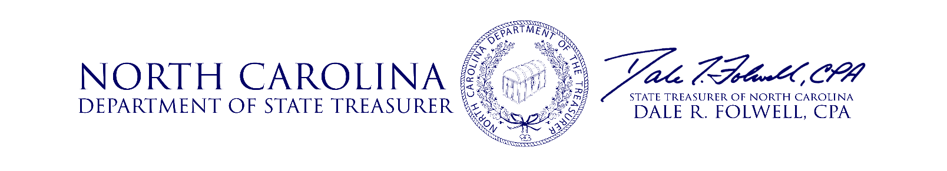

**Investment Advisory Committee Meeting**

**Agenda**

**November 15, 2018**

9:00 a.m. **Opening Remarks** Treasurer Folwell

9:05 a.m. **Approval of Minutes** Treasurer Folwell

9:10 a.m. **Performance Update** Christopher Morris, Chief Risk &

Operating Officer

Jeff Smith, Director of Fixed Income

9:40 a.m. **Investment Cost-Effectiveness Review** Alan Torrance, CEM Benchmarking, Inc.

Christopher Morris, Chief Risk &

Operating Officer

10:25 a.m. **I.G. Fixed Income Asset Class Review** Jeff Smith, Director of I.G. Fixed Income

10:50 a.m. **Opportunistic F.I. Asset Class Review** Ronald Funderburk, Director of

Opportunistic F.I. & I.S.

11:15 a.m. **IAC Member Q&A** IAC Members

11:25 a.m. **Public Comment** Treasurer Folwell

11:30 a.m. **Meeting Adjourned** Treasurer Folwell

**Date of Next Meeting**

The next Investment Advisory Committee meeting date will be February 20, 2019. More information regarding this meeting will be communicated.

**Questions**

Questions relating to the items on the agenda should be addressed to the Investment Management Division of the Department of State Treasurer at (919) 814-4330 or [gail.kadash@nctreasurer.com](mailto:gail.kadash@nctreasurer.com).