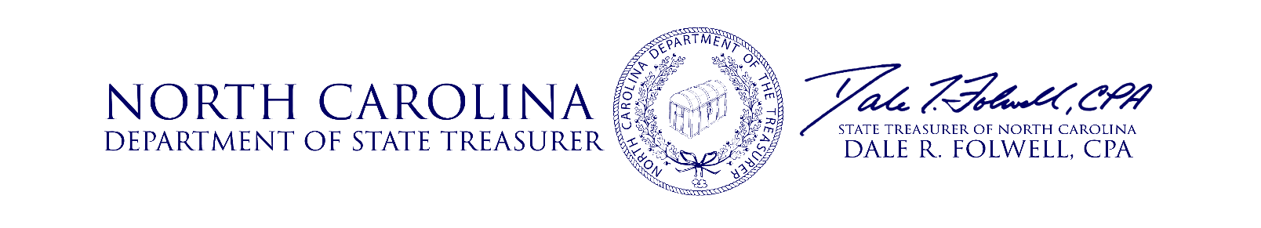

**Investment Advisory Committee Meeting**

**Agenda**

**August 16, 2018**

9:00 **Opening Remarks** Treasurer Folwell

9:05 **Approval of Minutes** Treasurer Folwell

9:10 **Resolution for Outgoing Members** Treasurer Folwell

9:15 **Performance Update** Christopher Morris, Chief Risk & Operating Officer

Jeff Smith, Director I.G. Fixed Income

10:00 **Public Equity Asset Class Review** Rhonda Smith, Director

10:40 **IAC Member Q&A** IAC Members

10:45 **Public Comment** Treasurer Folwell

10:50 **Meeting Adjourned** Treasurer Folwell

**Date of Next Meeting**

The next Investment Advisory Committee meeting date will be November 15, 2018. More information regarding this meeting will be communicated.

**Questions**

Questions relating to the items on the Agenda should be addressed to the Investment Management Division of the State Treasurer’s Office at (919) 814-4330 or by email at [gail.kadash@nctreasurer.com](mailto:gail.kadash@nctreasurer.com).