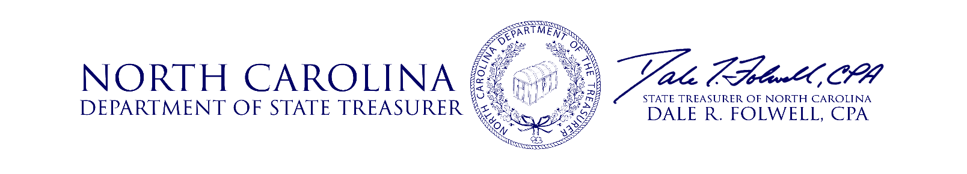

**Investment Advisory Committee Meeting**

**Agenda**

**May 17, 2018**

9:00 **Opening Remarks** Treasurer Folwell

9:05 **Approval of Minutes** Treasurer Folwell

9:10 **Performance Update** Christopher Morris, Dir. Risk & Asset Allocation

Jeff Smith, Director I.G. Fixed Income

9:50 **Private Equity Asset Class Review** Craig Demko, Director

10:20 **Private Market Discretionary**  Meryl Murtagh, Assistant General Counsel

**Investment Approval Process**

10:50 **Inflation Sensitive Asset Class Review** Ronald Funderburk, Director

11:20 **IAC Member Q&A** IAC Members

11:25 **Public Comment** Treasurer Folwell

11:30 **Meeting Adjourned** Treasurer Folwell

**Date of Next Meeting**

The next Investment Advisory Committee meeting date will be August 16, 2018. More information regarding this meeting will be communicated.

**Questions**

Questions relating to the items on the Agenda should be addressed to the Investment Management Division of the State Treasurer’s Office at (919) 814-4330 or by email at [gail.kadash@nctreasurer.com](mailto:gail.kadash@nctreasurer.com).